2021 Ocean County Irish Festival
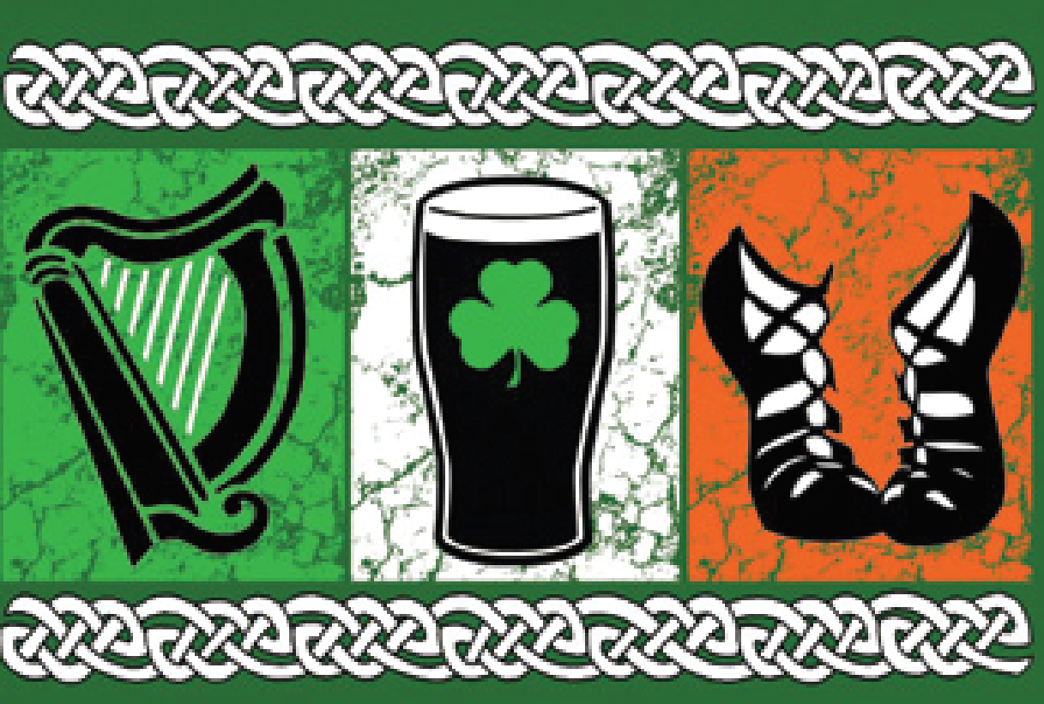
Saturday, September 11th Manahawkin Lake Park, Manahawkin, NJ
Please join us for the 5th annual Ocean County Irish Festival hosted by The Order of the Friendly Sons of the Shillelagh, Ocean County Chapter.
The Festival Planning Committee happily invites and encourages you to become a trusted, local sponsor for this yearly event which prides itself on donating a percentage of the proceeds to benefactors such as local schools and scholarships, Veteran Foundations, Local Food Banks, and other charitable organizations in need.
- One Day Event
- Free Admission / Parking
- 911 Remembrance
- “Irishman of the Year” selection
- Super 50/50 and 50/50s pulled throughout the Event
- Live music celebrating Irish Heritage the entire day
- Performances by Irish Step Dancers and the Emerald Society of Ocean County Pipe and Drum Band
- Over 15,000 people in attendance at the previous events
- Family and Pet friendly
- Great Vendor participation for Food, Games and Shopping
- Beer Garden including Wine, Ciders and Seltzers

Festival Sponsorship Plans
GRAND CELTIC PLAN - $2,500
- Banner Provided and Displayed on Entertainment Stage or Beer Garden (Choice).
- Mobile “Big Board” Logo’s Advertisement (Extra Large Font) with 30 Second Full Advertisement which will scroll throughout the Event.
- “Shout Outs” to open the Festival, between the bands, 50/50drawings and at the closing of the Event.
- Festival Website Listing with Business Link and Social Media preference mentions.
- Friendly Sons of the Shillelagh Newsletter Classification ad.
CELTIC PLAN - $1,000
- Mobile “Big Board” Logo’s Advertisement (Large Font) with 15 Second Full Advertisement which will scroll throughout the Event.
- “Shout Outs” between the bands and 50/50drawings.
- Festival Website Listing with Business Link and Social Media preference mentions.
- Friendly Sons of the Shillelagh Newsletter Classification ad.

*See other side
POT O’ Gold PLAN - $500
- Mobile “Big Board” Logo’s Advertisement (Large Font) with 10 Second Full Advertisement which will scroll throughout the Event.
- “Shout Outs” between the band and 50/50drawings.
- Festival Website Listing with Business Link and Social Media preference mentions.
- Friendly Sons of the Shillelagh Newsletter Classification ad.
SHAMROCK PLAN - $250
- Mobile “Big Board” Logo’s Advertisement (Medium Font) with 5 Second Shared Advertisement with other Shamrock Sponsors.
- Festival Website Listing with Business Link and Social Media preference mentions.
- Friendly Sons of the Shillelagh Newsletter Classification ad.
LEPRECHAUN PLAN - $100
- Mobile “Big Board” Logo’s Advertisement (Small Font) with 5 Second Shared Advertisement with other Leprechaun Sponsors.
- Festival Website Listing with Business Link and Social Media preference mentions.
- Friendly Sons of the Shillelagh Newsletter Classification ad.
_________________________________________________________________________________________________
Sponsor Information
Business Name (As wanted on Advertisement): _________________________________________________________
Address: ________________________________________________________________________________________
Contact Person: __________________________________________________________________________________
Contact Phone #: _________________________________________________________________________________
Email: __________________________________________________________________________________________
Website / URL (if applicable): ________________________________________________________________________
Type of Plan: _____________________________________________________________________________________

Please make checks payable to FSOS and mail your sponsorship form to the Friendly Sons of the Shillelagh, Ocean County Chapter, PO Box 1017, Manahawkin, NJ 08050. If easier, we can arrange pickup by your FSOS sponsor agent.
Sponsorship selection and payment can be done on the OCFSOS website www.oceanfsos.wildapricot.org and clicking on the link for 2021 Irish Festival Sponsorship. Payment can be made with 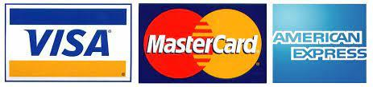.
The Friendly Sons of the Shillelagh, Ocean County Chapter is a 501c3 non-profit charitable organization and will provide a letter of confirm by request of your sponsorship for your records.
Any questions regarding the event, sponsorships and payments please reach out to Kenny Ward, Sponsorship Committee Chair, via phone at 732-735-4030 or by email to wardkenneth200@gmail.com.

WE LOOK FORWARD TO ANOTHER GREAT EVENT!
The Friendly Sons of the Shillelagh, Ocean County Chapter
PO Box 1017, Manahawkin, NJ 08050
www.oceanfsos.wildapricot.org
